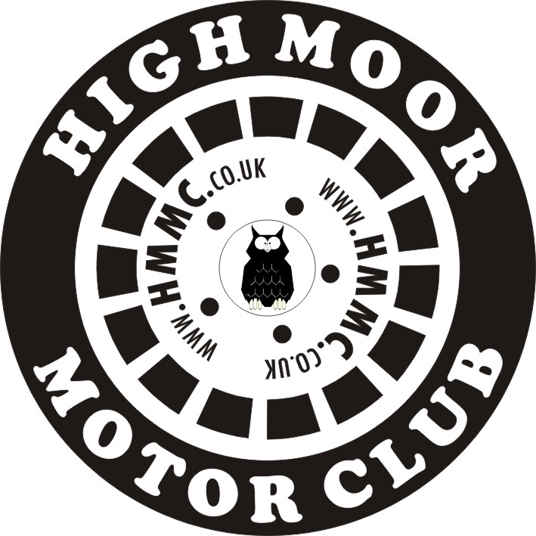

MEMBERSHIP FORM

New Member Renewal [Life]

Individual Membership : £5 ; Joint Membership (living at same address) : £7

I wish to apply for membership of High Moor Motor Club.

If accepted, I agree to abide by the Rules and Regulations of the MSA and
High Moor MC. A Copy of HMMC Rules will be given to me upon election.

Please fill in the following information to enable the Club to process your Membership application.
If JOINT MEMBERSHIP applied for, please complete details of BOTH applicants !!!
TITLE | Mr, Mrs,  Miss, Ms

FIRST NAME

SURNAME

DATE OF BIRTH
ADDRESS | House No &  Street
 | District
 | Town
 | County
 | POST CODE
TELEPHONE NO | Home
 | Work
 | Mobile
E-MAIL | E-Mail Address
SIGNATURE(S) OF
APPLICANT(S)

MEMBERSHIP FORM

COMPLETION DATE

Please SEND completed form AND relevant HMMC Membership Fee (Cheques payable to High Moor M.C) to :
GARY HESLOP, 33 ACRESFIELD ROAD, MIDDLETON, MANCHESTER. M24 2WT.
[ Home Tel : 0161 643 0151 ; Mobile : 07973 816965; ]
E-Mail Address : membership@hmmc.co.uk

Information completed above will be held on Computer.

Only HMMC members will be issued with any information disclosed on this form.

